LAB 5
SORTING AND FILTERING

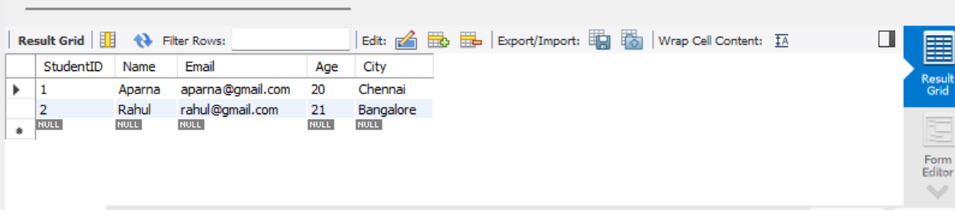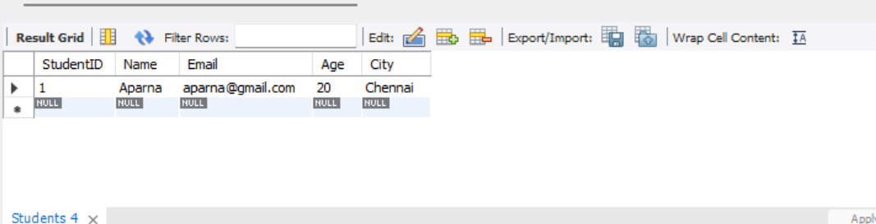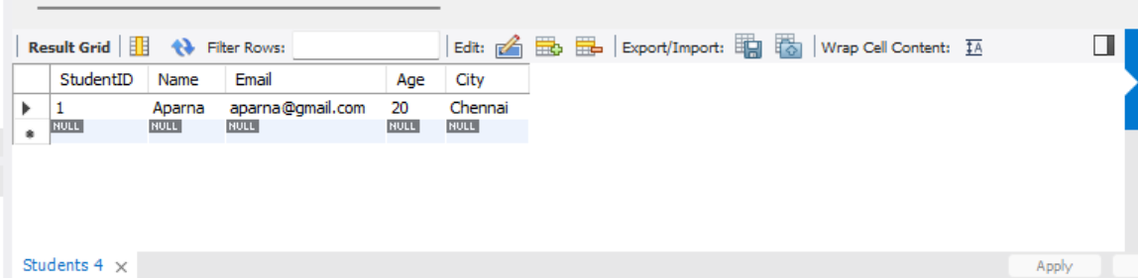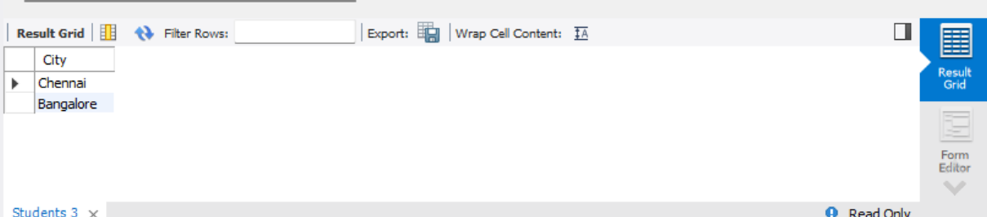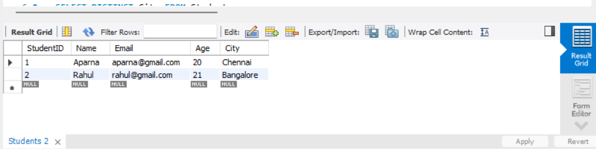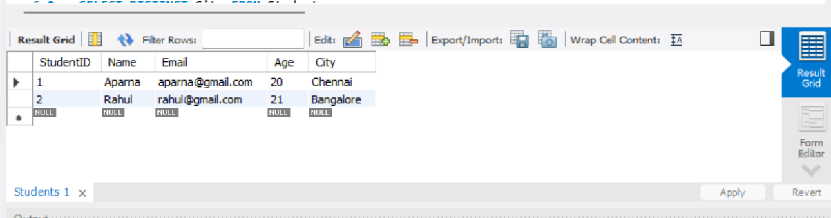

Explanation:
The ORDER BY clause is used to sort records in ascending or descending order. The WHERE clause is used to filter records based on a specified condition. The SELECT statement retrieves the required data from the Students table.
Result: Thus, sorting and filtering operations were performed successfully on the Students table.

